פרויקט ב'
תיעוד ריצות שונות
Resolution in Degrees: 0.0002777777777777778° x 0.0002777777777777778°
Resolution in Meters: 30.92m x 26.08m
Extent: BoundingBox(left=34.99986111111111, bottom=31.999861111111112, right=36.000138888888884, top=33.00013888888889)
ranges of elevations: [(-373, 1246)]
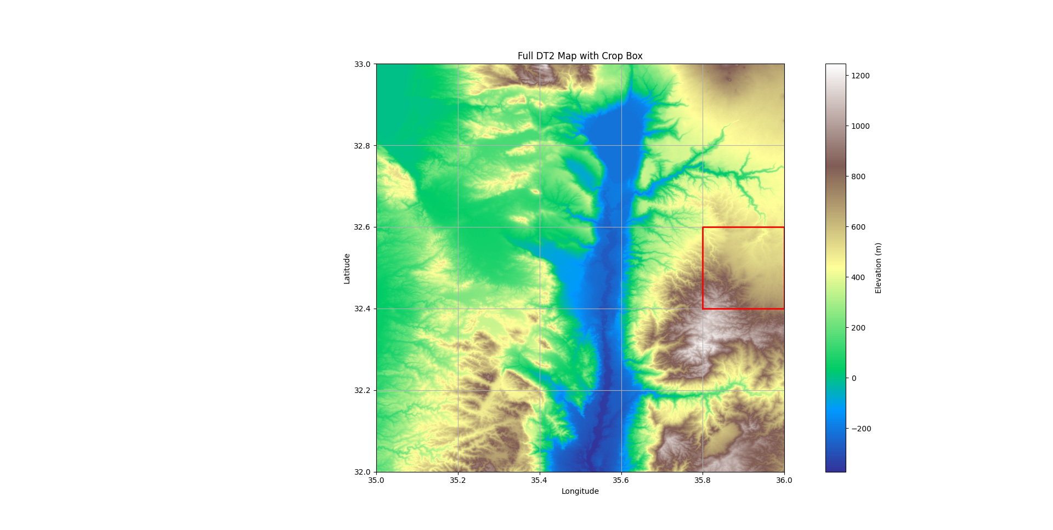
ranges of elevations_cropped: [(316, 1127)]

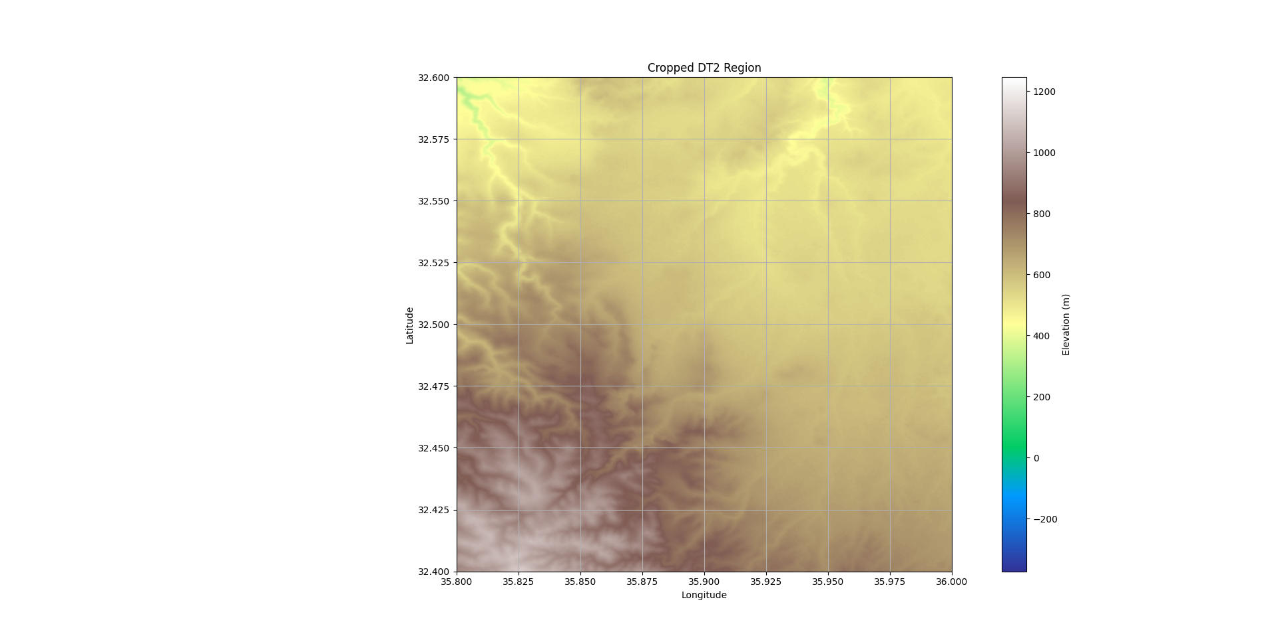

תהליך האימון:
ניסוי א –
num_total: 648, num_calib: 324, num_train:66, num_val:129, num_calib:324

